1. **Matrix Partitioner**
2. **Description**

**Map Task:**

1. For given Input ( i, j, V )
2. If J == 0,1,2 then Output -> Key: 0 Value:( i,j, V)
3. If J == 3,4,5 then Output -> Key:1 Value:( i,j, V)
4. If J == 6,7,8 then Output -> Key:2 Value:( i,j, V)

**Partitioner Task:**

1. No of Reducer Task == No of partitions
2. If Key = 0, Store all values in First Partition
3. If Key = 1, Store all values in Second Partition
4. If Key = 2, Store all values in Third Partition

**Reducer Task:**

1. Do Nothing Reducer Class
2. **Command**

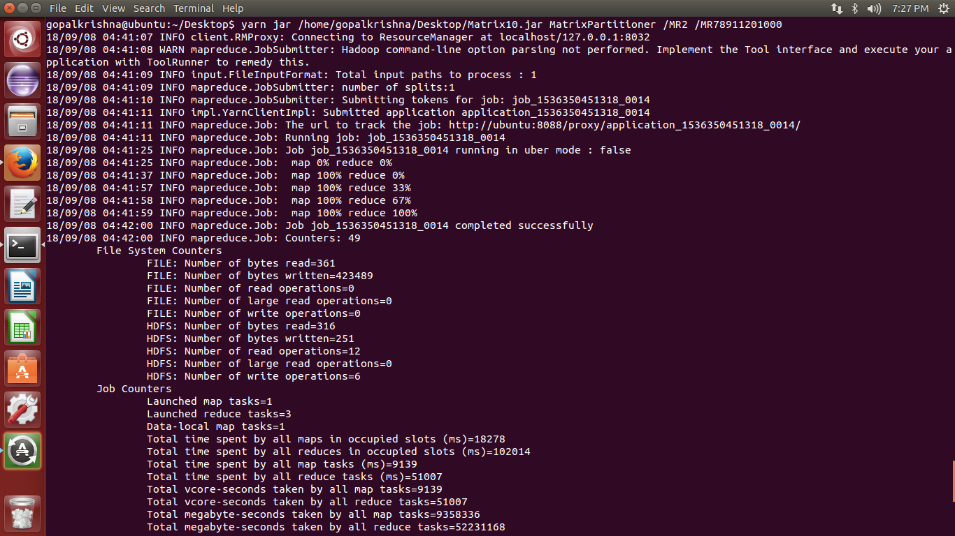

1. **Result**

